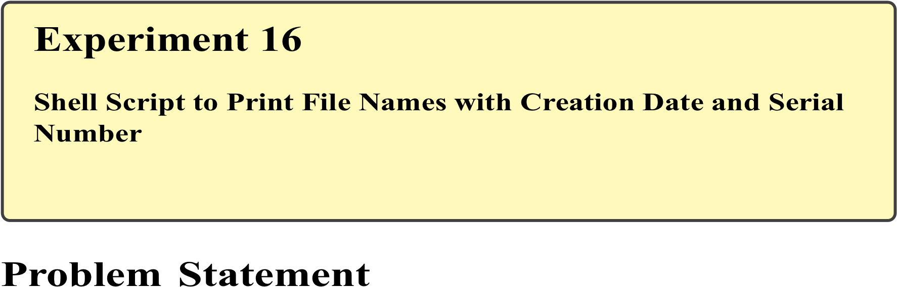
In Linux systems, administrators often need to list files along with their metadata such as creation or modification time in an organized and readable format. Displaying file names with serial numbers and timestamps is useful for auditing, reporting, backup verification, and log management. Automating this task using shell scripting improves efficiency and consistency.
The problem is to write a shell script that lists all files in a directory along with a serial number and their creation (or last modification) date, demonstrating file metadata handling and formatted output in Bash scripting.

Theory

File Timestamps in Linux
Linux maintains multiple timestamps for files:
- Access time (atime) – Last access
- Modification time (mtime) – Last content modification
- Change time (ctime) – Last metadata change
Note:
Traditional Linux file systems do not always store true creation time. Therefore, mtime or ctime is commonly used to represent file creation or update information.

Listing Files Programmatically
Using commands such as ls, stat, and loops, file information can be extracted and formatted within shell scripts.

Commands Used
ls | List directory contents
stat | Display detailed file information
awk | Text processing
date | Format timestamps
echo | Display formatted output

Procedure

A. Writing the Shell Script
- Open the terminal.
- Create a script file:
nano file_info.sh
- Enter the following script:
#!/bin/bash
count=1
echo "S.No File Name Date"
for file in * do
if [ -f "$file" ]; then
mod_date=$(stat -c %y "$file" | cut -d'.' -f1) echo "$count $file $mod_date" count=$((count + 1)) fi done
- Save and exit the editor.
- Make the script executable:
chmod +x file_info.sh

B. Executing the Script
6. Run the script in a directory containing files:
./file_info.sh
